

**SOFTWARE REQUIREMENT SPECIFICATION (SRS) SIGN-OFF**

**Authorization Memorandum**

This form is to sign-off completion of the Requirement Phase for **CAMPUS MANAGEMENT SOFTWARE AT WORLD SKILL CENTER (WSC).**

World Skill Centre (WSC) acknowledges receipt of the deliverables as part of the Requirement Phase through the submission of this document.

|  |  |
| --- | --- |
| **MODULE NAME** | **Finance and Accounting module (Procurement & Inventory Management)** |

| **VERSION HISTORY** | | | |
| --- | --- | --- | --- |
| **Version** | **Author** | **Date** | **Changes** |
|  |  |  |  |
|  |  |  |  |

**WSC AUTHORITY NAME AND**  **SIGNATURE**

**SOUL AUTHORITY NAME AND**  **SIGNATURE**

Pages 1 of 47

**Software Requirement Specification (SRS)**

Of

**Finance and Accounting module (Procurement & Inventory Management)**

For Implementation of

**Campus Management Software**

at

**World Skill Center (WSC)**

**Sustainable Outreach And Universal**

**Leadership (SOUL) Limited**

**Table of Content**

A. Abstract 3

B. Introduction 3

C. Definition, Acronyms and Abbreviations 3

D. Overview of the Document 3

E. Scope of Accounting Module 4

F. WSC Finance Accounting Process Flow 4

G. Process Flow Description 5

H. List of Screens and Their Descriptions 6

1. Procurement & Inventory Management Masters 7

1.1 Supplier 7

1.2 Purchase Invoice 12

2. Taxes 34

2.1 Tax Category 34

2.2 Item Tax Template 36

2.3 Purchase Taxes and Charges Template 37

2.4 Tax Rule 39

2.5 Tax Withholding Category 41

3. Bank Guarantee 43

3.1 Bank Guarantee 43

# Abstract

Software Requirements Gathering is one of the first phases of system development. This phase results in the Software Requirements Specification (SRS) document, which must contain a complete, concise, high-quality description of the system being considered.

# Introduction

The World Skill Center (WSC) is a premier advanced skill training institute established by the Government of Odisha, Skill Development and Technical Education Department, through the Odisha Skill Development Authority (OSDA). The WSC will impart advanced skill training in eight trades from engineering and service sectors. WSC caters primarily to induct the best talent from ITIs and Polytechnics and train them to become globally employable in emerging areas such as "Industry 4.0". WSC is housed in a state-of-the-art, 18-storey, air-conditioned building with nearly half a million square feet of space in the heart of capital city of Bhubaneswar.

With the Implementation of campus management software for WSC the goal is to streamline the operations and functions of the campus by integrating various processes, such as admissions, course registration, academic progress tracking, and financial management, HRMS, Procurement and Inventory management, etc into a unified system. The implementation also aims at providing a user-friendly interface for all stakeholders, making it easier for them to access the necessary information and complete their tasks with ease. The modules to be covered during the implementation of the software includes:

|  |  |
| --- | --- |
| Students Management Modules | Infrastructure Management |
| Academic System | Finance and Accounting System |
| Procurement & Inventory Management | Training and Placement |
| Human Resources Management System | Application Integration |

# Definition, Acronyms and Abbreviations

The following table explains the terms and abbreviations used in the document:

|  |  |
| --- | --- |
| **Abbreviation** | **Description** |
| SRS | Software Requirements Specification |
| R | Rename - When a field is Renamed |
| N | New - When a New field is Added |
| D | Delete - When an Existing field is Deleted |
| NA | Not Applicable |

# Overview of the Document

This requirement document provides a detailed overview of the functional requirements of a project. It serves as a communication tool between stakeholders, including developers, project managers, and end-users. The purpose of this requirement document is to define and document the project's objectives, scope, and expectations, and to ensure that all stakeholders have a clear understanding of what the project entails.

This document covers all the functional requirements of the **Finance and Accounting module** considering all transactions in **Procurement and Inventory management module** of ERP Product. This helps in organizing the manage data regarding Supplier, Purchase Invoice, Taxes, Tax Category, Item Tax Template, Purchase Taxes and Charges Template, Tax Rule, Tax Withholding Category, etc.

# Scope of Accounting Module

* Receipt and Payment Entries
* Direct Transfer of Caution Money to Student’s Accounts
* Demand Register
* Caution Money Register
* Bank Reconciliation Statement
* Generation of Cash Book (PL)
* Grants-in-aid Register
* Paid Voucher Register
* Advances Register
* Auditing and Tracking Pendency of Audit paras etc.

# WSC Finance Accounting Process Flow

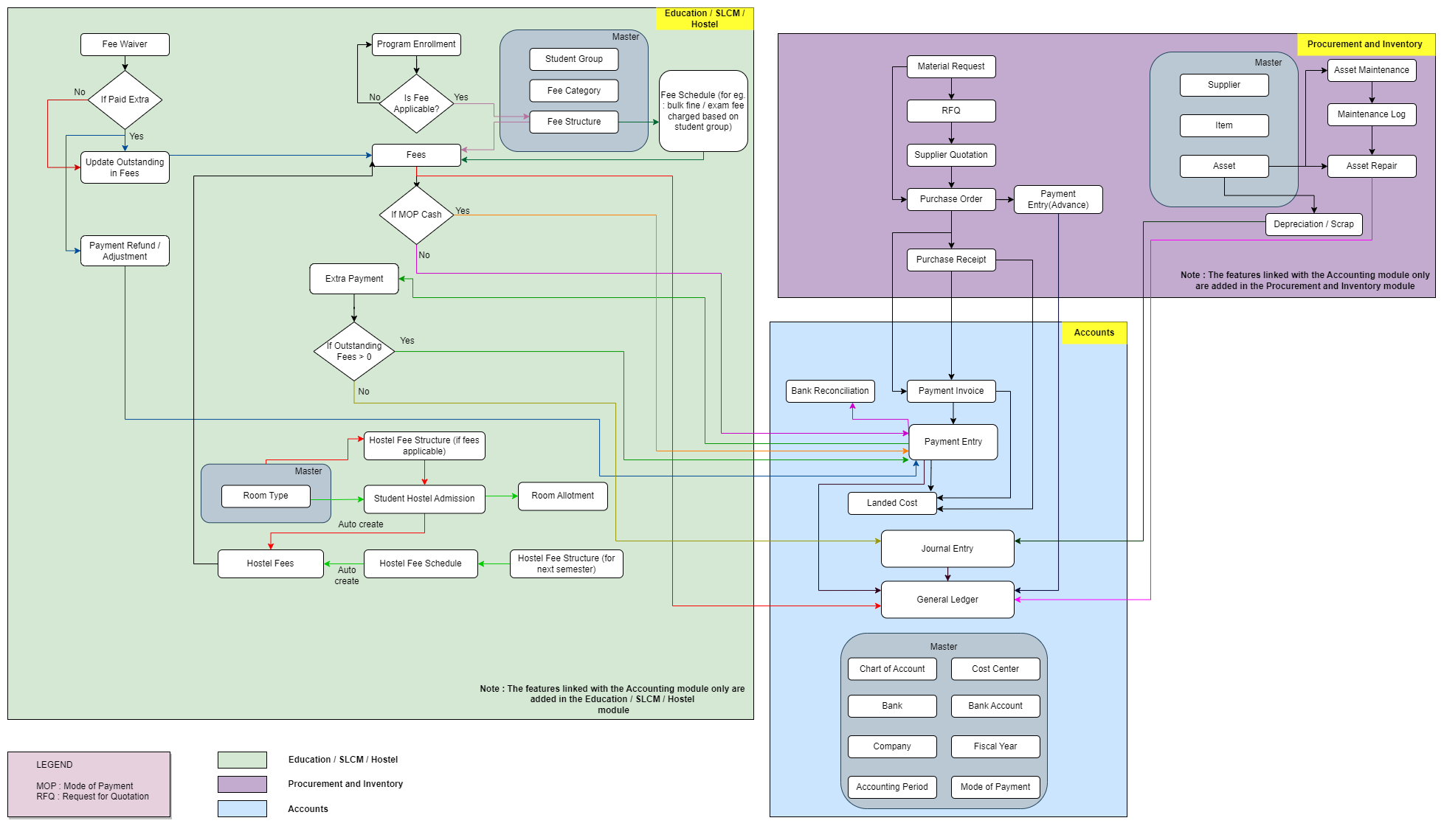

Note : The features linked with the Accounting Module are added in this flowchart

# **Process Flow Description**

**Accounts Masters**

Accounts Master represents the configuration such as Chart of Accounts, Cost center, Bank, Bank Account, Company, Fiscal Year, Accounting Period , Mode of Payment etc.

**SLCM Masters**

Student Group, Fee Category and Fee Structure are the masters which are required for the functioning of the accounts module.

**Procurement and Inventory Masters**

Supplier, Item and Asset are the master which are essential for the accounting processes to be functional with respect to the Material Management module.

**Fee Waiver**

Fee waiver refers to an exemption or reduction of a student's fees that they would normally be required to pay in order to enroll in classes or participate in certain activities.

**Fees**

In this form, Fee Records of the students can be maintained.

**Fee Schedule**

Fee Schedule would help in defining a time-line for the Fee payment of the students, based on the Student Group.

**Payment Invoice**

A Purchase Invoice is a bill you receive from your Suppliers against which you need to make the payment.

**Payment Entry**

Payment Entry is a record indicating that payment has been made for an invoice.

Payment Entry can be made against the following transactions:

1. Sales Invoice
2. Purchase Invoice
3. Purchase Order (Advance Payment)
4. Expense Claim
5. Internal Transfer

**Bank Reconciliation**

Once all your bank transactions are imported into the application, you can reconcile them with your existing vouchers.

**Journal Entry**

A Journal Entry is an entry made in the general ledger and it indicates the affected accounts.

**General Ledger**

The General Ledger is a detailed report for all transactions posted to each account and for every transaction there is a Credit and Debit account so it lists them all up.

# **List of Screens and Their Descriptions**

|  |  |  |
| --- | --- | --- |
| **ID** | **Screen Name** | **Description** |
|  | Supplier | Suppliers are companies or individuals who provide you with products or services. |
|  | Purchase Invoice | **A Purchase Invoice is a bill you receive from your Suppliers against which you need to make the payment.** |
|  | Tax Category | A Tax Category allows applying one or more Tax Rules to transactions based on various criteria. |
|  | Item Tax Template | Item Tax Template is useful for item wise taxation. |
|  | Purchase Taxes and Charges Template | Purchase Taxes and Charges may be applied to any item you buy. |
|  | Tax Rule | A Tax Rule automatically applies taxes to transactions based on preset rules. |
|  | Tax Withholding Category | Tax Withholding Category is Tax Deducted at Source. |

## Procurement & Inventory Management Masters

### Supplier

**General Description**

The Following table describe overall information about this screen:

|  |  |
| --- | --- |
| **Description :** | Suppliers are companies or individuals who provide you with products or services. |
| **Navigation :** | Home > Accounts > Accounts Payable > Supplier |
| **Pre-requisites :** | 1. Supplier Group 2. Country 3. Billing Currency 4. Bank Account 5. Price List 6. Payment Term 7. Tax Category 8. Tax Withholding Category 9. Company |

**Screenshot**

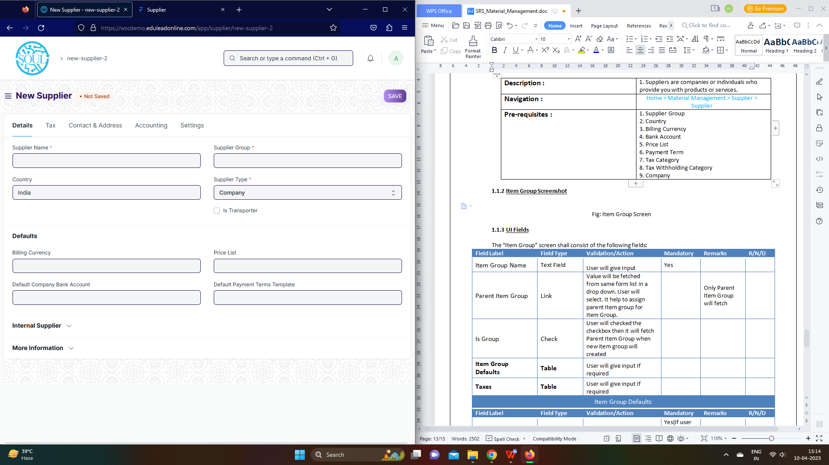

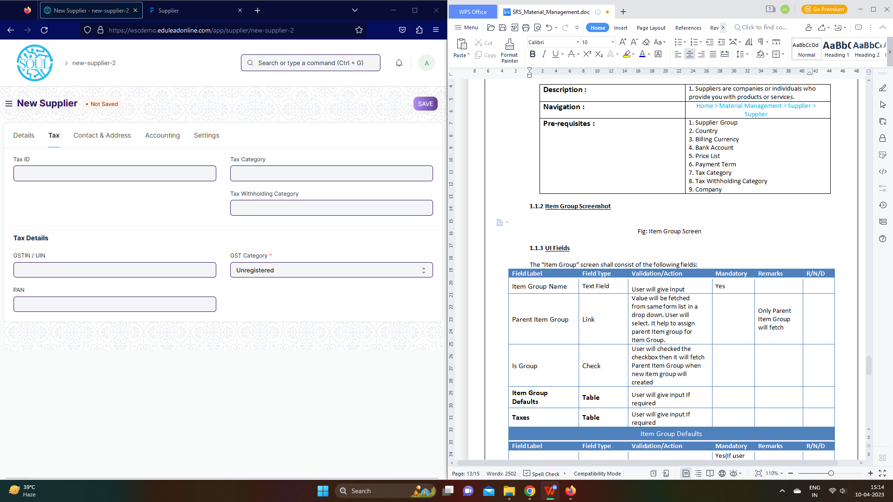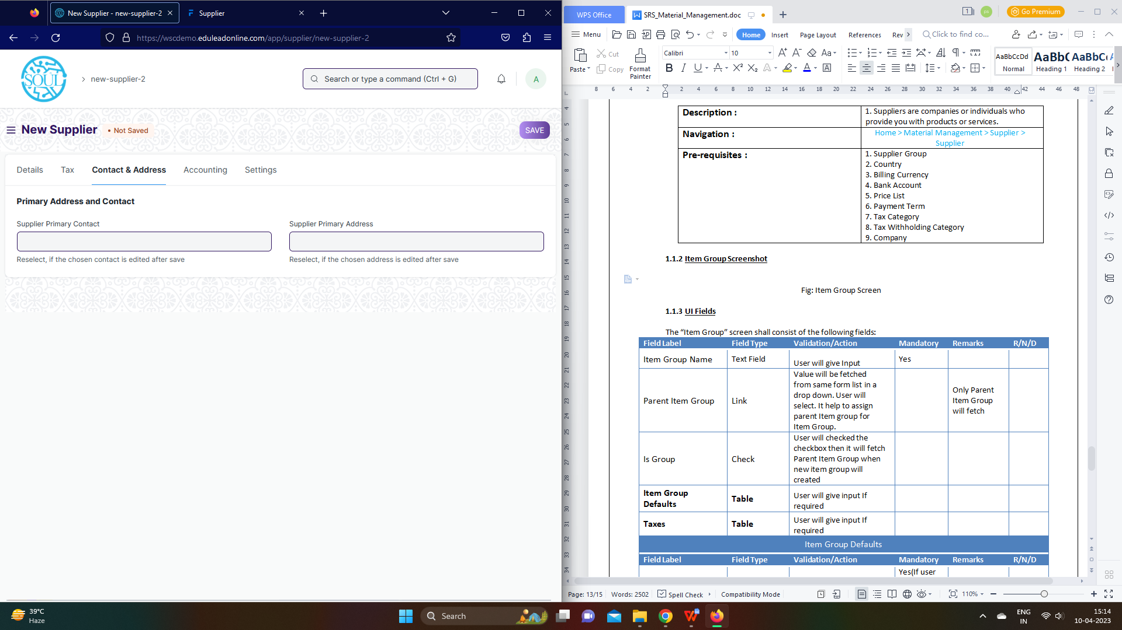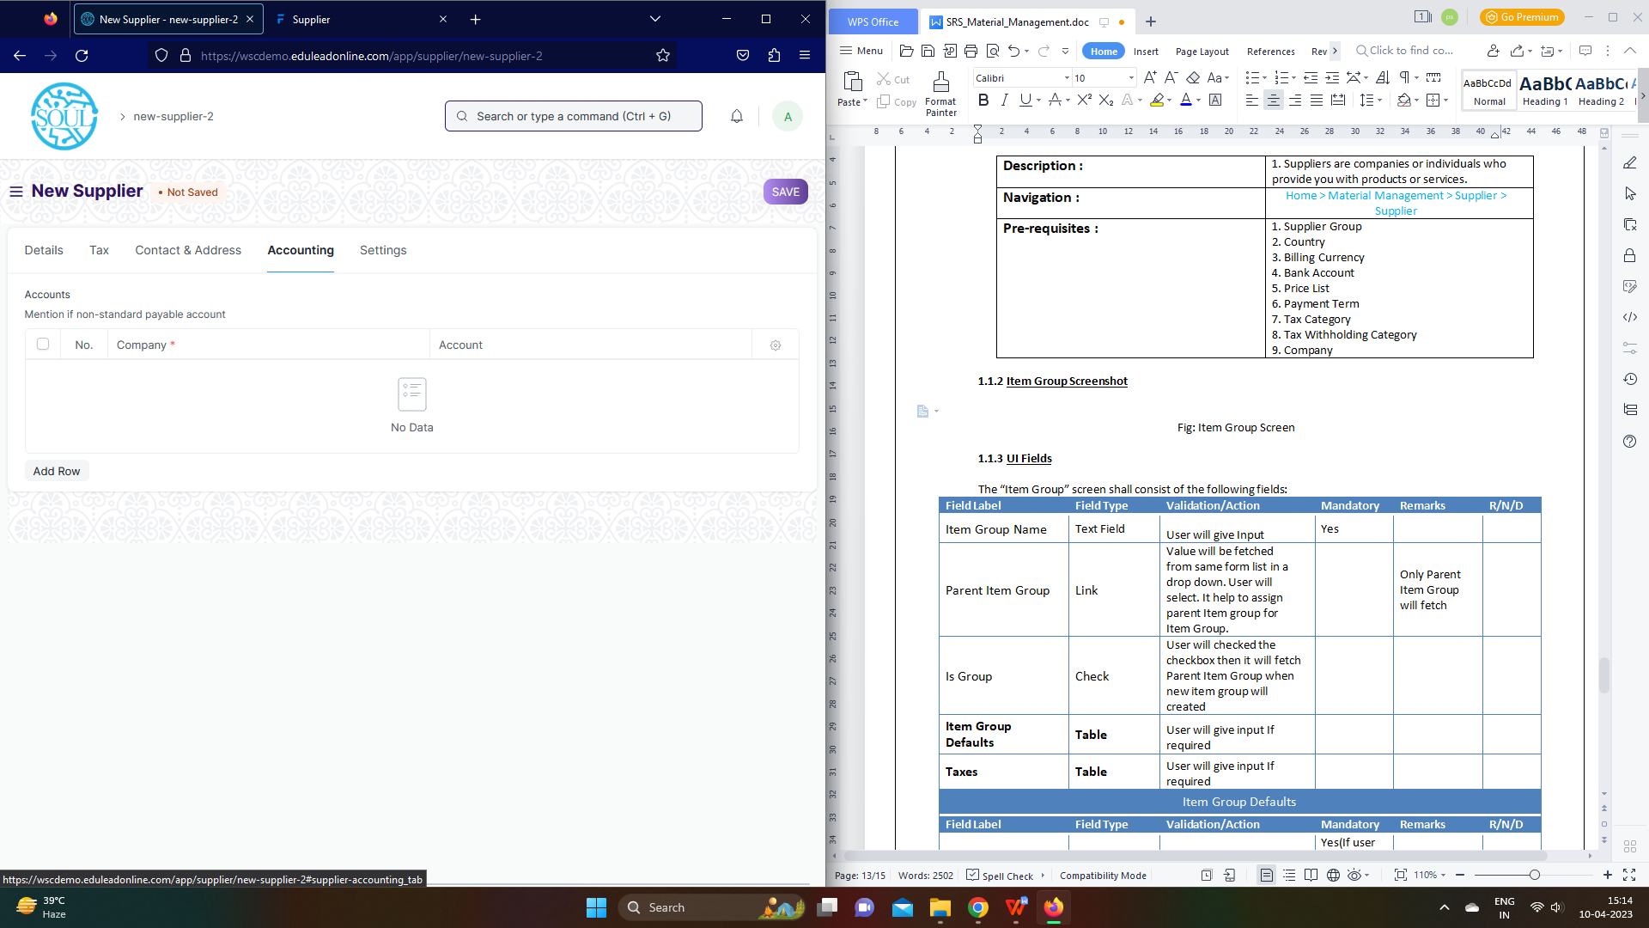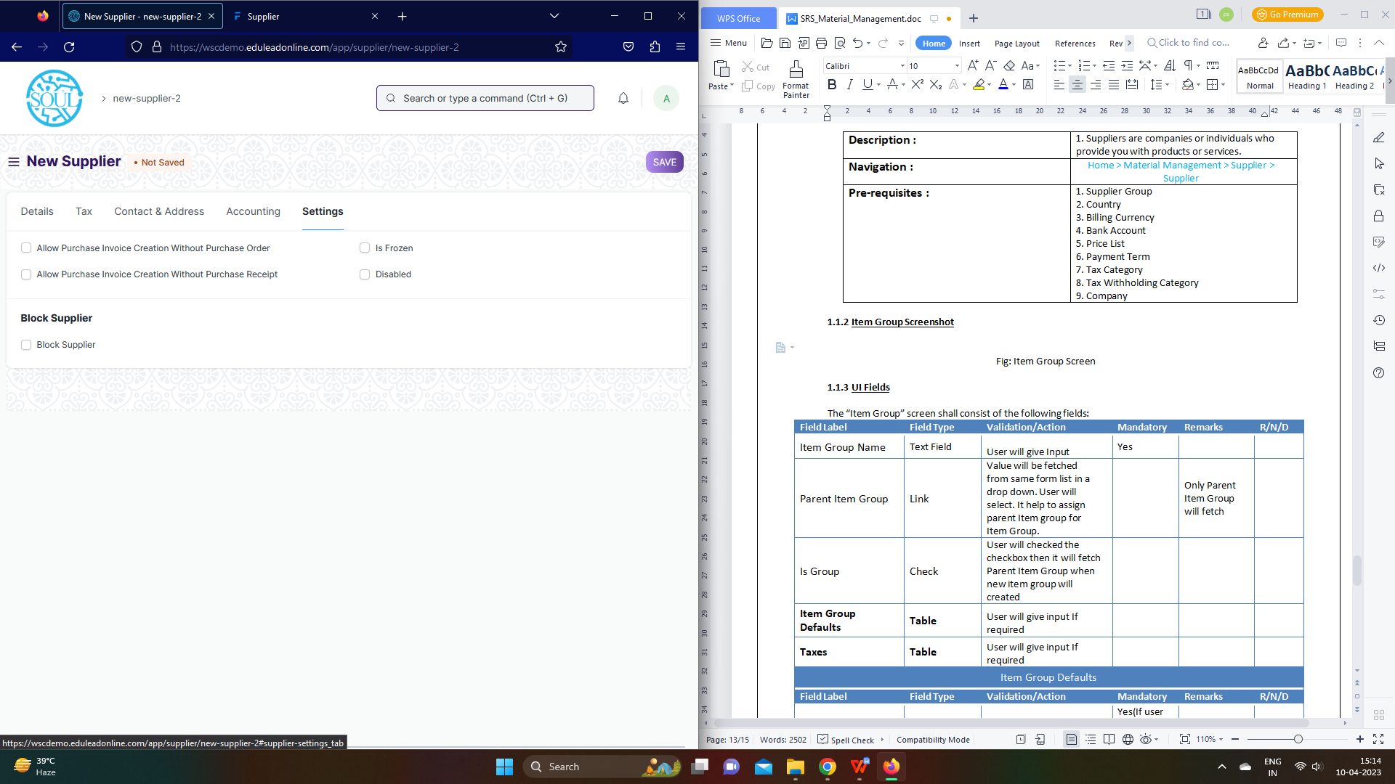

Figure: Supplier

**UI Fields**

The “Supplier” screen shall consist of the following fields:

|  |  |  |  |  |  |  |  |  |  |  |
| --- | --- | --- | --- | --- | --- | --- | --- | --- | --- | --- |
| **ID** | **Field Label** | | **Field Type** | **Validation/ Action** | | | **Mandatory** | **Remarks** | | **R/N/D** |
|  | Supplier Name | | Text Field | User Input | | | Yes |  | |  |
|  | Country | | Link Field | Fetched from Country screen | | |  |  | |  |
|  | Supplier Group | | Link Field | Fetched from Supplier Group screen | | | Yes |  | |  |
|  | Supplier Type | | Drop down | Company/ Individual | | | Yes |  | |  |
|  | Is Transporter | | Checkbox | User Input | | |  |  | |  |
|  | Image | | Attach Image | 1. On attachment a dialogue box will be popup where user can attach the files, take the picture with the help camera and can link any URL.   If photos or images attached then the size will be maximum 200 kb | | |  |  | |  |
|  | Billing Currency | | Link Field | Fetched from Currency screen | | |  |  | |  |
|  | Default Company Bank Account | | Link Field | Fetched from Currency screen | | |  |  | |  |
|  | Price List | | Link Field | Fetched from Price List screen | | |  |  | |  |
|  | Default Payment Terms Template | | Link Field | Fetched from Currency screen | | |  |  | |  |
|  | Is Internal Supplier | | Checkbox | User Input | | |  |  | |  |
|  | Represents Company | | Link Field | Fetched from Company screen | | |  |  | |  |
|  | **Allowed To Transact With** | | **Table** |  | | |  | These table is describe below | |  |
|  | Supplier Details | | Text Field | User Input | | |  |  | |  |
|  | Website | | Text Field | Field | | |  |  | |  |
|  | Print Language | | Link Field | Fetched from Language screen | | |  |  | |  |
|  | Tax ID | | Text Field | User Input | | |  |  | |  |
|  | Tax Category | | Link Field | Fetched from Tax Category screen | | |  |  | |  |
|  | Tax Withholding Category | | Link Field | Fetched from Tax Withholding Category screen | | |  |  | |  |
|  | GSTIN / UIN | | Text Field | User Input | | |  |  | |  |
|  | PAN | | Text Field | User Input | | |  |  | |  |
|  | GST Category | | Drop down | Registered Regular / Registered Composition / Unregistered /  SEZ / Overseas /  Deemed Export /  UIN Holders / Tax Deductor | | | Yes |  | |  |
|  | GST Transporter ID | | Text Field | User Input | | |  |  | |  |
|  | Address HTML | | HTML | User Input | | |  |  | |  |
|  | Contact HTML | | HTML | User Input | | |  |  | |  |
|  | Supplier Primary Contact | | Link Field | Fetched from Contact screen | | |  |  | |  |
|  | Mobile No | | Read Only | Will be fetched based on Contact selection | | |  |  | |  |
|  | Email Id | | Read Only | Will be fetched based on Contact selection | | |  |  | |  |
|  | Supplier Primary Address | | Link Field | Fetched from Address screen | | |  |  | |  |
|  | Primary Address | | Text field | User Input | | |  |  | |  |
|  | **Accounts** | | **Table** |  | | |  | These table is describe below | |  |
|  | Allow Purchase Invoice Creation Without Purchase Order | | Checkbox | User Input | | |  |  | |  |
|  | Allow Purchase Invoice Creation Without Purchase Receipt | | Checkbox | User Input | | |  |  | |  |
|  | Is Frozen | | Checkbox | User Input | | |  |  | |  |
|  | Disabled | | Checkbox | User Input | | |  |  | |  |
|  | Warn RFQs | | Checkbox | User Input | | |  |  | |  |
|  | Warn POs | | Checkbox | User Input | | |  |  | |  |
|  | Prevent RFQs | | Checkbox | User Input | | |  |  | |  |
|  | Prevent POs | | Checkbox | User Input | | |  |  | |  |
|  | Block Supplier | | Checkbox | User Input | | |  |  | |  |
|  | Hold Type | | Drop down | All / Invoices / Payments | | |  |  | |  |
|  | Release Date | | Date | User Input | | |  |  | |  |
|  | View | | Button | Account Ledger: On click of this button you will be able to see the account ledger for suppliers | | |  |  | |  |
|  | Account Payable: On click of this button you will be able to see the payment details for suppliers | | |  |  | |  |
|  | Create | | Bank Account: On click of this button you will be bale to create bank account | | |  | Finance department will be given access to create accounts | |  |
|  | Pricing rule: On click of this button you will be able to see pricing rule for items | | |  | Part of sales module | |  |
|  | Actions | | Get Supplier group details: on click of this button you will see details of supplier group that the supplier is linked to | | |  |  | |  |
|  | **Accounts(Child Table)** | | | | | | | | | |
| **ID** | | **Field Label** | **Field Type** | | **Validation/ Action** | **Mandatory** | | **Remarks** | **R/N/D** | |
| 1. | | Company | Link | | Fetched from Company screen | Yes | |  |  | |
| 2. | | Account | Link | | Fetched from Account screen |  | |  |  | |

**Note:**

1. Fields to be present in supplier form will be shared by WSC Procurement team, So that it will

customized in ERP form and the template could be shared by SOUL Team to WSC for sharing to

their Suppliers which could be used to Import data

**Users: Roles and Permissions**

The following table describes the users and their roles and permissions for the screens :

|  |  |  |  |  |  |  |  |  |  |
| --- | --- | --- | --- | --- | --- | --- | --- | --- | --- |
| **ID** | **Role** | **Select** | **Read** | **Write** | **Create** | **Delete** | **Submit** | **Cancel** | **Amend** |
|  | Accountant Admit | Yes | Yes | Yes | Yes | Yes | Yes | Yes | Yes |
|  | Account Manager | Yes | Yes | Yes | Yes | Yes | Yes | Yes | Yes |
|  | Account User | Yes | Yes | Yes | Yes | Yes | Yes | Yes | Yes |

### Purchase Invoice

**General Description**

|  |  |
| --- | --- |
| **Description :** | **A Purchase Invoice is a bill you receive from your Suppliers against which you need to make the payment.** |
| **Navigation :** | Home > Accounts > Accounts Payable > Purchase Invoice |
| **Pre-requisites :** | 1. Item 2. Supplier 3. Purchase Order 4. Purchase Receipt (Optional) |

**Purchase Invoice Screenshot**

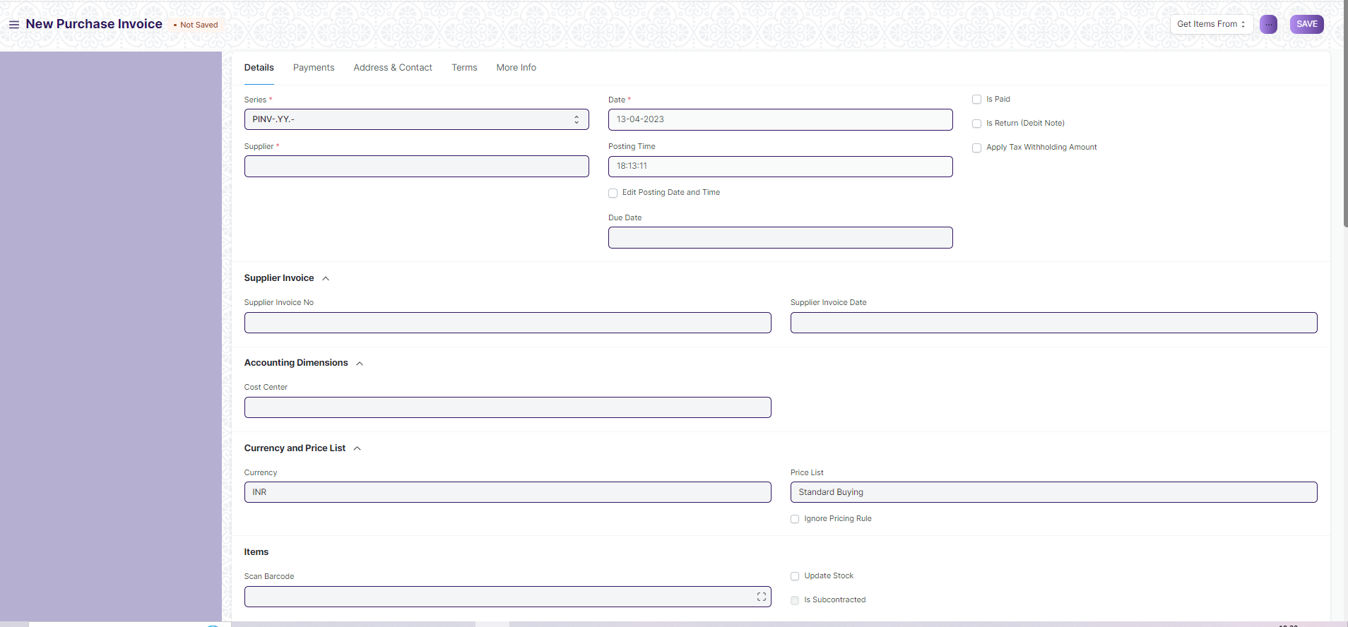

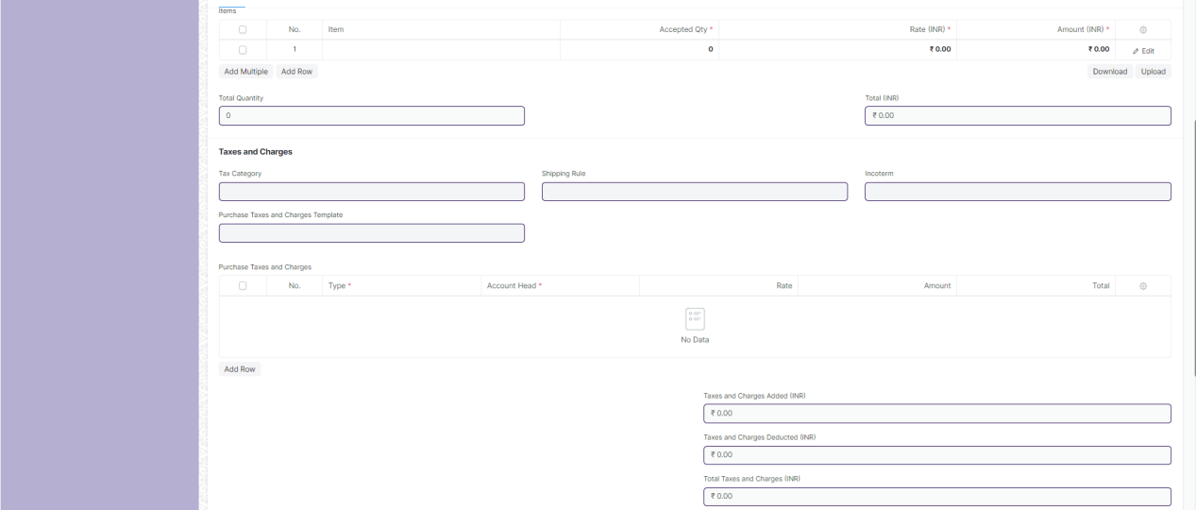

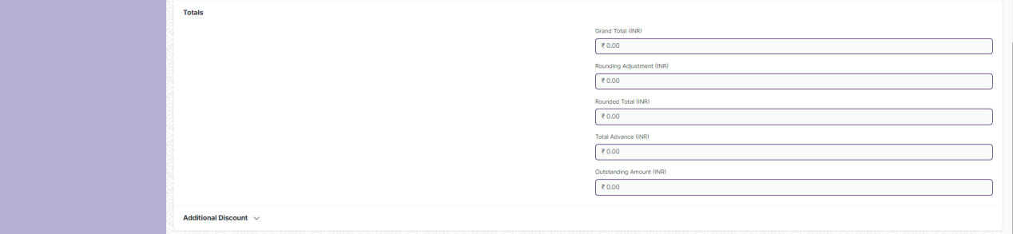

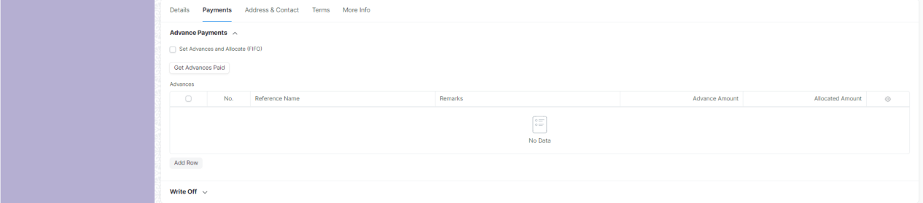

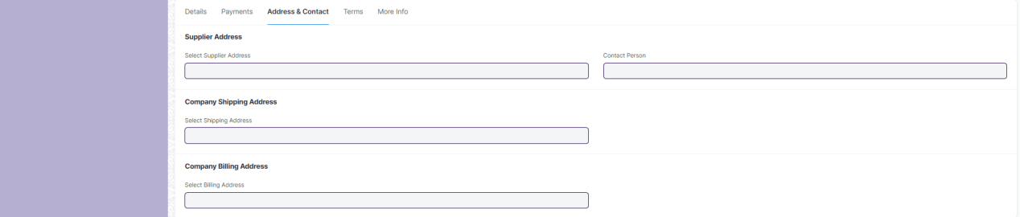

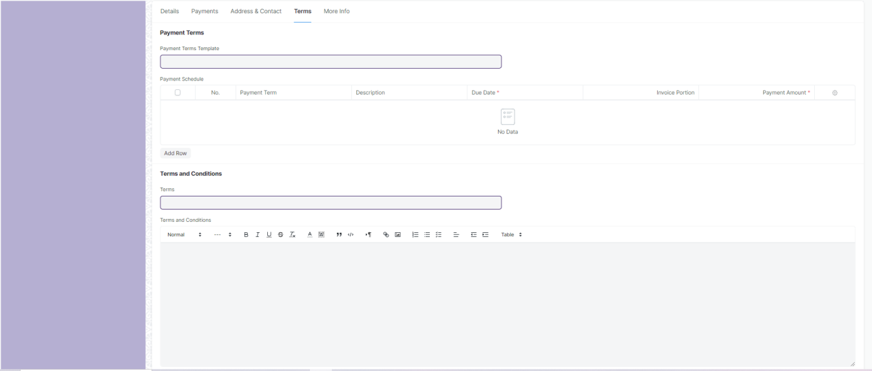

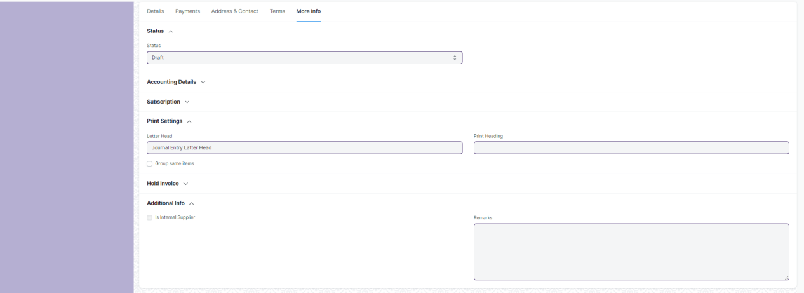

Figure: Purchase Invoice

**UI Fields**

|  |  |  |  |  |  |  |
| --- | --- | --- | --- | --- | --- | --- |
| **ID** | **Field Label** | **Field Type** | **Validation/Action** | **Mandatory** | **Remarks** | **R/N/D** |
|  | Series | Dropdown | * PINV-.YY.- * PRET-.YY.- * ACC-PINV-.YYYY.- * ACC-PINV-RET-.YYYY.-   (“PINV-.YY.-” are default value but user will select any one) | Yes |  |  |
|  | Supplier | Link | Value will fetched from Supplier and user will select any one | Yes |  |  |
|  | Supplier Name | Text List (Read Only) | Value will auto fetch when Supplier field value given |  |  |  |
|  | Tax Id | Read Only | Value will auto fetch when Supplier field value given |  |  |  |
|  | Company | Link | Value will fetched from Company |  |  |  |
|  | Date | Date Picker | Value will auto fetch but user can able to edit If Checked “Edit Posting Date and Time” field | Yes |  |  |
|  | Posting Time | Time | Value will auto fetch but user can able to edit If Checked “Edit Posting Date and Time” field |  |  |  |
|  | Edit Posting Date and Time | Checkbox | If Checked “Edit Posting Date and Time” field then user can edit Date and Posting Time |  |  |  |
|  | Due Date | Date Picker | User will give date |  |  |  |
|  | Is Paid | Checkbox | If checked then Payment is done and Due Date field will be hide |  |  |  |
|  | Is Return (Debit Note) | Checkbox | If Checked, return will applied against purchase Invoice |  |  |  |
|  | Return Against Purchase Invoice | Link (Read Only) | Field will visible when “Is Return” is checked and Value will fetched from Purchase Invoice. User will select any one |  |  |  |
|  | Apply Tax Withholding Amount | Checkbox | If Checked, it applied for Tax Withholding Category |  |  |  |
|  | Tax Withholding Category | Link | Value will fetched from “Tax Withholding Category” and user will select any one |  |  |  |
|  | Supplier Invoice No | Text Field | User will give input |  |  |  |
|  | Supplier Invoice Date | Date Picker | User will give date |  |  |  |
|  | Cost Center | Link | Value will fetched from “Cost Center” and user will select any one |  |  |  |
|  | Currency | Link | Currency will auto fetch but user can able to change |  |  |  |
|  | Exchange Rate | Number | When you select other Country currency then this field will fetch and value will given but user can able to change |  |  |  |
|  | Price List | Link | Value will fetch from Price list |  |  |  |
|  | Price List Currency | Link (Read Only) | Value will fetch from currency when Price List field value are given and Price List form value are given for other country |  |  |  |
|  | Price List Exchange Rate | Number | Field are visible when Price List field value are given and Price List form value are given for other country and User can able to change the value |  |  |  |
|  | Ignore Pricing Rule | Checkbox | If checked then it ignore pricing rule |  |  |  |
|  | Scan Barcode | Number | User will give input. By Reader or camera user will also give input |  |  |  |
|  | Update Stock | Checkbox | If checked, stock will update |  |  |  |
|  | Set Accepted Warehouse | Link | This field will visible if checked update stock. Value will fetched from Warehouse and user will select any one |  |  |  |
|  | Set From Warehouse | Link | If Supplier will be internal then this filed will be visible and value will fetched from Warehouse and user will select any one |  |  |  |
|  | Is Subcontracted | Checkbox (Read Only) | If Checked, Subcontracted is applied |  |  |  |
|  | Rejected Warehouse | Link | Value will fetched from Warehouse and user will select any one |  |  |  |
|  | Supplier Warehouse | Link | If Checked “Is Subcontracted” then this field visible and value will fetched from Warehouse and user will select any one |  |  |  |
|  | **Items** | **Table** |  | Yes | This table is describe below |  |
|  | Total Quantity | Number (Read Only) | Value will fetch according to Item child table field value. |  |  |  |
|  | Total Net Weight | Number (Read Only) | Value will fetch according to Item child table field value. |  |  |  |
|  | Total (Company Currency) | Currency (Read Only) | Value will fetch according to Item child table field value. |  |  |  |
|  | Net Total (Company Currency) | Currency (Read Only) | Value will fetch according to Item child table field value. |  |  |  |
|  | Total | Currency (Read Only) | Value will fetch according to Item child table field value. |  |  |  |
|  | Net Total | Currency (Read Only) | Value will fetch according to Item child table field value. |  |  |  |
|  | Tax Category | Link | Value will fetched from Tax Category and user will select any one |  |  |  |
|  | Purchase Taxes and Charges Template | Link | Value will fetched from Purchase Taxes and Charges Template and user will select any one |  |  |  |
|  | Shipping Rule | Link | Value will fetched from Shipping Rule and user will select any one |  |  |  |
|  | Incoterm | Link | Value will fetched from Incoterm and user will select any one |  |  |  |
|  | Named Place | Text Field | Field will visible when Incoterm value given. User will give input |  |  |  |
|  | **Purchase Taxes and Charges** | **Table** | Value will fetch according to “Purchase Taxes and Charges Template” field value |  | This table is describe below for manual process |  |
|  | Taxes and Charges Added (Company Currency) | Currency (Read Only) | Value will fetch according to “Purchase Taxes and Charges”child table field value. |  |  |  |
|  | Taxes and Charges Deducted (Company Currency) | Currency (Read Only) | Value will fetch according to “Purchase Taxes and Charges”child table field value. |  |  |  |
|  | Total Taxes and Charges (Company Currency) | Currency (Read Only) | Value will fetch according to “Purchase Taxes and Charges”child table field value. |  |  |  |
|  | Taxes and Charges Added | Currency (Read Only) | Value will fetch according to “Purchase Taxes and Charges”child table field value. |  |  |  |
|  | Taxes and Charges Deducted | Currency (Read Only) | Value will fetch according to “Purchase Taxes and Charges”child table field value. |  |  |  |
|  | Total Taxes and Charges | Currency (Read Only) | Value will fetch according to “Purchase Taxes and Charges”child table field value. |  |  |  |
|  | Grand Total (Company Currency) | Currency (Read Only) | Value will fetch automatically according to other field |  |  |  |
|  | Rounding Adjustment (Company Currency) | Currency (Read Only) | Value will fetch automatically according to other field |  |  |  |
|  | Rounded Total (Company Currency) | Currency (Read Only) | Value will fetch automatically according to other field |  |  |  |
|  | In Words (Company Currency) | Text Field (Read Only) | Value will fetch automatically according to Grand Total (Company Currency) field |  |  |  |
|  | Grand Total | Currency (Read Only) | Value will fetch automatically according to other field |  |  |  |
|  | Rounding Adjustment | Currency (Read Only) | Value will fetch automatically according to other field |  |  |  |
|  | Rounded Total | Currency (Read Only) | Value will fetch automatically according to other field |  |  |  |
|  | In Words | Text Field (Read Only) | Value will fetch automatically according to Grand Total field |  |  |  |
|  | Total Advance | Currency (Read Only) | Value will auto fetch when payment is done in advance |  |  |  |
|  | Outstanding Amount | Currency (Read Only) | Value will auto fetch when payment is pending |  |  |  |
|  | Disable Rounded Total | Checkbox | If checked Rounding Adjustment is not applicable |  |  |  |
|  | Apply Additional Discount On | Dropdown | * Grand Total * Net Total   (Grand Total are default value but user can able to change into Net Total) |  |  |  |
|  | Additional Discount Amount (Company Currency) | Currency (Read Only) | Value will auto fetch according to the discount |  |  |  |
|  | Additional Discount Percentage | Number | User will give Input |  |  |  |
|  | Additional Discount Amount | Currency | User will give Input |  |  |  |
|  | **Tax Withheld Vouchers** | **Table (Read Only)** | Value fetched automatically based on the tax templates and tax rules that have been set up in the system. |  | This table is describe below |  |
|  | Taxes and Charges Calculation | Long Text (Read Only) | After all tax calculation value will auto fetch |  |  |  |
|  | **Pricing Rule Detail** | **Table** **(Read Only)** | Auto fetch according to Pricing rule |  | This table is describe below |  |
|  | **Supplied Items** | **Table** | Auto fetch according to Supplied Items |  | This table is describe below |  |
|  | Mode of Payment | Link | If amount is paid value will fetch |  |  |  |
|  | Paid Amount (Company Currency) | Currency (Read Only) | If amount is paid value will fetch |  |  |  |
|  | Clearance Date | Date Picker (Read Only) | If amount is paid value will fetch |  |  |  |
|  | Cash/Bank Account | Link | If amount is paid value will fetch |  |  |  |
|  | Paid Amount | Currency | If amount is paid value will fetch |  |  |  |
|  | Set Advances and Allocate (FIFO) | Checkbox | If checked, then it applied for FIFO and “Get Advances Paid” Button will hide |  |  |  |
|  | Get Advances Paid | Button | When user will click button then value will fetch on Advance Table |  |  |  |
|  | **Advances** | **Table** |  |  | This table is describe below |  |
|  | Write Off Amount | Currency | User will give input |  |  |  |
|  | Write Off Amount (Company Currency) | Currency (Read Only) | Value will auto fetch from write off amount |  |  |  |
|  | Write Off Account | Link | Field will visble when user give value on Write Off Amount and value will fetch from Account and user will select one |  |  |  |
|  | Write Off Cost Center | Link | Field will visble when user give value on Write Off Amount and value will fetch from Cost Center and user will select one |  |  |  |
|  | Select Supplier Address | Link | Value will fetched from Address and user will select any one |  |  |  |
|  | Address | Small Text (Read Only) | Value will fetch when Supplier Address field value given |  |  |  |
|  | Supplier GSTIN | Text Field (Read Only) | After selecting the Supplier, this value will be auto fetch |  |  |  |
|  | GST Category | Text Field (Read Only) | After selecting the Supplier, this value will be auto fetch |  |  |  |
|  | Contact Person | Link | Value will fetched from Contact and user will select any one |  |  |  |
|  | Contact | Small Text (Read Only) | Value will fetch when Contact Person field value given |  |  |  |
|  | Mobile No | Small Text (Read Only) | Value will fetch when Contact Person field value given |  |  |  |
|  | Contact Email | Small Text (Read Only) | Value will fetch when Contact Person field value given |  |  |  |
|  | Select Shipping Address | Link | After selecting the Supplier, this value will be auto fetch but user can able to edit |  |  |  |
|  | Shipping Address | Small Text (Read Only) | After selecting the Supplier, this value will be auto fetch |  |  |  |
|  | Select Billing Address | Link | After selecting the Supplier, this value will be auto fetch but user can able to edit |  |  |  |
|  | Billing Address | Small Text (Read Only) | After selecting the Supplier, this value will be auto fetch |  |  |  |
|  | Company GSTIN | Text Field (Read Only) | After selecting the Supplier, this value will be auto fetch |  |  |  |
|  | Place of Supply | Text Field (Read Only) | After selecting the Supplier, this value will be auto fetch |  |  |  |
|  | Payment Terms Template | Link | After selecting the Supplier, this value will be auto fetch but user can able to edit |  |  |  |
|  | **Payment Schedule** | **Table** | Value will fetch according to “Payment Terms Template” field value |  | This table is describe below for manual process |  |
|  | Terms | Link | Value will fetched from “Terms and Conditions” and user will select any one |  |  |  |
|  | Terms and Conditions | Text Editor | Value will fetch when “Terms and Conditions” field value given and User can able to edit |  |  |  |
|  | Status | Dropdown | * Draft * Return * Debit Note Issued * Submitted * Paid * Partly Paid * Unpaid * Overdue * Cancelled * Internal Transfer   (It will auto fetch according to the form condition) |  |  |  |
|  | Credit To | Link | Value will fetched from Account and user will select any one | Yes |  |  |
|  | Is Opening Entry | Dropdown | * Yes * No   (User will select one) |  |  |  |
|  | Unrealized Profit / Loss Account | Link | User will give input if supplier is internal |  |  |  |
|  | Auto Repeat | Link (Read Only) | Auto Repeat the Purchase Invoice at specified intervals.(After submitting the form it will visible) |  |  |  |
|  | Update Auto Repeat Reference | Button | When value are present in Auto Repeat field then this button are visible. User will click and update Auto Repeat |  |  |  |
|  | From Date | Date Picker | User will give date |  |  |  |
|  | To Date | Date Picker | User will give date |  |  |  |
|  | Letter Head | Link | Value will fetched from Letter Head and user will select any one |  |  |  |
|  | Group same items | Checkbox | If checked then grouped same item |  |  |  |
|  | Print Heading | Link | Value will fetched from Print Heading and user will select any one |  |  |  |
|  | Print Language | Text Field (Read Only) | Value will auto fetch when give supplier name In supplier field |  |  |  |
|  | Hold Invoice | Checkbox | If Checked, Invoice will be on hold. |  |  |  |
|  | Release Date | Date Picker | When Hold Invoice is checked then this field will visible and user will give date |  |  |  |
|  | Reason For Putting On Hold | Small Text | When Hold Invoice is checked then this field will visible and user will give input |  |  |  |
|  | Is Internal Supplier | Checkbox (Read Only) | If checked then supplier will be internal |  |  |  |
|  | Represents Company | Link | Value will auto fetch from Company |  |  |  |
|  | Inter Company Invoice Reference | Link (Read Only) | Value will auto fetch from Company |  |  |  |
|  | Remarks | Small Text | User will give input |  |  |  |
|  | Create | Button | Purchase receipt: On click of this button you will be able to create Purchase receipt |  |  |  |
|  | Return/ Debit note: On click of this button you can create return or debit note |  |  |  |
|  | Subscription: Subscription: On click of this button you can create subscription for the Purchase receipt |  |  |  |
|  | View | Button | Accounting Ledger: On click of this button you will be able to see Accounting Ledger |  |  |  |
|  | **Items** | | | | | |
| ID | **Field Label** | **Field Type** | **Validation/Action** | **Mandatory** | **Remarks** | **R/N/D** |
|  | Item | Link | Value will fetched from Item and user will select any one |  |  |  |
|  | Product Bundle | Link (Read Only) | Value will auto fetch from Product Bundle according to the Item |  |  |  |
|  | Item Name | Text Field | Value will fetch when user will give Item Code field input but user can edit | Yes |  |  |
|  | Description | Text Editor | Value will fetch when user will give Item Code field input but user can edit |  |  |  |
|  | HSN/SAC | Text Field | Value will fetch when user will give Item Code field input but user can edit |  |  |  |
|  | Is Nil Rated or Exempted | Checkbox | Tax is not applicable if checked |  | Tax is applicable for all item | D |
|  | Is Non GST | Checkbox | If checked, For an item that is not covered under GST |  |  |  |
|  | Item Group | Link (Read Only) | Value will fetch when user will give Item Code field input |  |  |  |
|  | Image View | Image | Image will fetch when user will give Item Code field input |  |  |  |
|  | Received Qty | Number (Read Only) | Value will fetch when user will give Item Code field input |  |  |  |
|  | Accepted Qty | Number | Value will fetch when user will give Item Code field input | Yes |  |  |
|  | Rejected Qty | Number | Value will fetch when user will give Item Code field input |  |  |  |
|  | UOM | Link Field | Value will fetch when user will give Item Code field input but user can edit | Yes |  |  |
|  | UOM Conversion Factor | Number (Read Only) | Value will fetch when user will give UOM field input but user can edit | Yes |  |  |
|  | Stock UOM | Link (Read Only) | Value will fetch when user will give UOM field input |  |  |  |
|  | Accepted Qty in Stock UOM | Number (Read Only) | Value will fetch when user will give UOM field input | Yes |  |  |
|  | Price List Rate | Currency (Read Only) | Value will fetch when user will give Item Code field input but user can edit |  |  |  |
|  | Price List Rate (Company Currency) | Currency (Read Only) | Value will fetch when user will give Item Code field input |  |  |  |
|  | Margin Type | Dropdown | * Percentage * Amount   (User will select one) |  |  |  |
|  | Margin Rate or Amount | Number | Field will visible when user will give input to Margin Type field |  |  |  |
|  | Rate With Margin | Currency (Read Only) | Field will visible when user will give input to Margin Rate or Amount field |  |  |  |
|  | Discount on Price List Rate (%) | Percent | User will give Input |  |  |  |
|  | Discount Amount | Currency | User will give Input |  |  |  |
|  | Rate With Margin (Company Currency) | Currency (Read Only) | Field will visible when user will give input to Margin Type field |  |  |  |
|  | Rate | Currency | Value will fetch when user will give Item Code field input but user can edit | Yes |  |  |
|  | Amount | Currency (Read Only) | Value will fetch when user will give Item Code field input | Yes |  |  |
|  | Item Tax Template | Link Field | Value will fetched from Item Tax Template and user will select any one |  |  |  |
|  | Rate (Company Currency) | Currency (Read Only) | Value will fetch when user will give Item Tax Template field input | Yes |  |  |
|  | Amount (Company Currency) | Currency (Read Only) | Value will fetch when user will give Item Tax Template field input | Yes |  |  |
|  | Rate of Stock UOM | Currency (Read Only) | Value will fetch when user will give Item Tax Template field input |  |  |  |
|  | Is Free Item | Checkbox (Read Only) | If Checked, Item will be free of cost |  |  |  |
|  | Apply TDS | Checkbox | If Checked, TDS will applied for that item |  |  |  |
|  | Net Rate | Currency (Read Only) | Value will fetch when user will give Item Code field input |  |  |  |
|  | Net Amount | Currency (Read Only) | Value will fetch when user will give Item Code field input |  |  |  |
|  | Net Rate (Company Currency) | Currency (Read Only) | Value will fetch when user will give Item Code field input |  |  |  |
|  | Net Amount (Company Currency) | Currency (Read Only) | Value will fetch when user will give Item Code field input |  |  |  |
|  | Landed Cost Voucher Amount | Currency (Read Only) | Value will fetch when user will give Item Code field input |  |  |  |
|  | Accepted Warehouse | Link Field | Value will fetched from Warehouse and user will select any one |  |  |  |
|  | Quality Inspection | Link Field | Value will fetched from Quality Inspection and user will select any one |  |  |  |
|  | Serial No | Text | User will give input |  |  |  |
|  | Rejected Warehouse | Link Field | Value will fetched from Warehouse and user will select any one |  |  |  |
|  | Batch No | Link Field | Value will fetch when user will give Item Code field input But user can able to change |  |  |  |
|  | Rejected Serial No | Text | User will give input |  |  |  |
|  | Manufacturer | Link Field |  |  | It is for a Manufacture module | D |
|  | Manufacturer Part Number | Text Field |  |  | It is for a Manufacture module | D |
|  | Expense Head | Link Field | Value will fetched from Account and user will select any one |  |  |  |
|  | Asset Location | Link Field | Value will fetched from Location and user will select any one |  |  |  |
|  | Asset Category | Link (Read Only) | Value will fetch when user will give Item Code field input |  |  |  |
|  | Deferred Expense Account | Link Field | This field will visible when Enable Deferred Expense Checked, User will give input |  |  |  |
|  | Service Stop Date | Date Picker | This field will visible when Enable Deferred Expense Checked, User will give date |  |  |  |
|  | Enable Deferred Expense | Checkbox | If Checked, then applied for deferred expense |  |  |  |
|  | Service Start Date | Date Picker | This field will visible when Enable Deferred Expense Checked, User will give date |  |  |  |
|  | Service End Date | Date Picker | This field will visible when Enable Deferred Expense Checked, User will give date |  |  |  |
|  | Allow Zero Valuation Rate | Checkbox | If Checked, valuation will be zero |  |  |  |
|  | BOM | Link (Read Only) |  |  | It is for a Manufacture module | D |
|  | Include Exploded Items | Checkbox (Read Only) | Value will fetch when user will give Item Code field input |  |  |  |
|  | Purchase Invoice Item | Text Field (Read Only) | Value will fetch when user will give Item Code field input |  |  |  |
|  | Purchase Order | Link (Read Only) | Value will fetch when user will give Item Code field input |  |  |  |
|  | Purchase Receipt | Link (Read Only) | Value will fetch when user will give Item Code field input |  |  |  |
|  | Sales Invoice Item | Text Field (Read Only) | Value will fetch when user will give Item Code field input |  |  |  |
|  | Weight Per Unit | Number | User will give Input |  |  |  |
|  | Total Weight | Number (Read Only) | Value will fetch when user will give Item Code field input |  |  |  |
|  | Weight UOM | Link Field | Value will fetched from Account and user will select any one |  |  |  |
|  | Address | Link Field | Value will fetched from Address and user will select any one |  |  |  |
|  | Article | Link Field | Value will fetched from Article and user will select any one |  |  |  |
|  | Project | Link Field | Value will fetched from Project and user will select any one |  |  |  |
|  | About Us Team Member | Link Field |  |  | It’s not link with any form, Value will not fetch from anywhere | D |
|  | Cost Center | Link Field | Value will fetched from Cost Center and user will select any one |  |  |  |
|  | Page Break | Checkbox | If checked then Page Break will create a page break just before this item when printing |  |  |  |
|  | **Purchase Taxes and Charges** | | | | | |
|  | **Field Label** | **Field Type** | **Validation/Action** | **Mandatory** | **Remarks** | **R/N/D** |
|  | Consider Tax or Charge for | Dropdown | * Valuation and Total * Valuation * Total   (“Total” are default value but user can able to change into “Valuation and Total”  or “Valuation”) | Yes |  |  |
|  | Add or Deduct | Dropdown | * Add * Deduct   (“Add” are default value but user can able to change into “Deduct”) | Yes |  |  |
|  | Type | Dropdown | * Actual * On Net Total * On Previous Row Amount * On Previous Row Total * On Item Quantity   (“On Net Total”are default value but user can able to change into other) | Yes |  |  |
|  | Reference Row # | Text Field | If tax is based on "Previous Row Total" User can select the row number which will be taken as a base for this calculation |  |  |  |
|  | Is this Tax included in Basic Rate? | Checkbox | If checked, the tax amount will be considered as already included in the Print Rate / Print Amount |  |  |  |
|  | Considered In Paid Amount | Checkbox | If checked, considered in paid amount |  |  |  |
|  | Account Head | Link Field | Value will fetched from Account and user will select any one | Yes |  |  |
|  | Description | Long Text | Value will auto fetch when we give value in Account Head field but user can edit | Yes |  |  |
|  | Rate | Number | Value will auto fetch when we give value in Account Head field but user can edit |  |  |  |
|  | Address | Link Field | Value will fetched from Address and user will select any one |  |  |  |
|  | Article | Link Field | Value will fetched from Article and user will select any one |  |  |  |
|  | Cost Center | Link Field | Value will auto fetch when we give value in Account Head field but user can edit |  |  |  |
|  | About Us Team Member | Link Field |  |  | It’s not link with any form,  Value will not fetch from anywhere | D |
|  | Account Currency | Link Field(Read Only) | Value will auto fetch when we give value in Account Head field |  |  |  |
|  | Amount | Currency | Value will auto fetch when we give value in Account Head field but user can edit |  |  |  |
|  | Tax Amount After Discount Amount | Currency (Read Only) | Value will auto fetch when we give value in Account Head field but user can edit |  |  |  |
|  | Total | Currency (Read Only) | Value will auto fetch when we give value in Account Head field but user can edit |  |  |  |
|  | Amount (Company Currency) | Currency (Read Only) | Value will auto fetch when we give value in Account Head field but user can edit |  |  |  |
|  | Tax Amount After Discount Amount | Currency (Read Only) | Value will auto fetch when we give value in Account Head field but user can edit |  |  |  |
|  | **Tax Withheld Vouchers** | | | | | |
|  | **Field Label** | **Field Type** | **Validation/Action** | **Mandatory** | **Remarks** | **R/N/D** |
|  | Voucher Type | Link Field | Value fetched automatically based on the tax templates and tax rules that have been set up in the system. |  |  |  |
|  | Voucher Name | Link Field | Value fetched automatically based on the tax templates and tax rules that have been set up in the system. |  |  |  |
|  | Taxable Amount | Currency | Value fetched automatically based on the tax templates and tax rules that have been set up in the system. |  |  |  |
|  | **Pricing Rule Detail** | | | | | |
|  | **Field Label** | **Field Type** | **Validation/Action** | **Mandatory** | **Remarks** | **R/N/D** |
|  | Pricing Rule | Link Field | Value will auto fetch from Pricing Rule if it is applicable for account |  |  |  |
|  | Item Code | Text Field | Value will auto fetch according Pricing Rule |  |  |  |
|  | Rule Applied | Checkbox | If Checked, rule will applied for account pricing |  |  |  |
|  | **Supplied Items** | | | | | |
|  | **Field Label** | **Field Type** | **Validation/Action** | **Mandatory** | **Remarks** | **R/N/D** |
|  | Item Code | Link Field | Value auto fetch When transfer Material to Supplier |  |  |  |
|  | Raw Material Item Code | Link Field | Value auto fetch When transfer Material to Supplier |  |  |  |
|  | Stock Uom | Link Field | Value auto fetch When transfer Material to Supplier |  |  |  |
|  | Reserve Warehouse | Link Field | Value auto fetch When transfer Material to Supplier |  |  |  |
|  | BOM Detail No | Text Field |  |  | It is for a Manufacture module | D |
|  | Reference Name | Text Field | Value auto fetch When transfer Material to Supplier |  |  |  |
|  | Rate | Currency | Value auto fetch When transfer Material to Supplier |  |  |  |
|  | Amount | Currency | Value auto fetch When transfer Material to Supplier |  |  |  |
|  | Required Qty | Number | Value auto fetch When transfer Material to Supplier |  |  |  |
|  | Supplied Qty | Number | Value auto fetch When transfer Material to Supplier |  |  |  |
|  | Consumed Qty | Number | Value auto fetch When transfer Material to Supplier |  |  |  |
|  | Returned Qty | Number | Value auto fetch When transfer Material to Supplier |  |  |  |
|  | **Advances** | | | | | |
|  | **Field Label** | **Field Type** | **Validation/Action** | **Mandatory** | **Remarks** | **R/N/D** |
|  | Reference Type | Link Field(Read Only) | When user click “Get Advances Paid” button then value will fetch |  |  |  |
|  | Reference Name | Link Field(Read Only) | When user click “Get Advances Paid” button then value will fetch |  |  |  |
|  | Remarks | Text (Read Only) | When user will click “Get Advances Paid” button then value will fetch |  |  |  |
|  | Advance Amount | Currency (Read Only) | When user will click “Get Advances Paid” button then value will fetch |  |  |  |
|  | Allocated Amount | Currency | When user will click “Get Advances Paid” button then value will fetch but user can edit |  |  |  |
|  | Exchange Gain/Loss | Currency (Read Only) | When user will click “Get Advances Paid” button then value will fetch |  |  |  |
|  | Reference Exchange Rate | Number (Read Only) | When user will click “Get Advances Paid” button then value will fetch |  |  |  |
|  | **Payment Schedule** | | | | | |
|  | **Field Label** | **Field Type** | **Validation/Action** | **Mandatory** | **Remarks** | **R/N/D** |
|  | Payment Term | Link Field | Value will fetched from Payment Term and user will select any one |  |  |  |
|  | Description | Small Text | Value will give input |  |  |  |
|  | Due Date | Date Picker | Value will auto fetch when user give input in Payment Term field but user can able to edit | Yes |  |  |
|  | Mode of Payment | Link Field | Value will auto fetch when user give input in Payment Term field but user can able to edit |  |  |  |
|  | Invoice Portion | Percent | Value will auto fetch when user give input in Payment Term field but user can able to edit |  |  |  |
|  | Discount Type | Select | * Percentage * Amount   (Percentage Is default value but user can change into Amount) |  |  |  |
|  | Discount Date | Date Picker | Value will auto fetch when user give input in Discount field but user can able to edit |  |  |  |
|  | Discount | Number | User will give Input |  |  |  |
|  | Payment Amount | Currency | Value will auto fetch when user give input in Payment Term field but user can able to edit | Yes |  |  |
|  | Outstanding | Currency (Read Only) | Value will auto fetch when user give input in Payment Term field |  |  |  |
|  | Paid Amount | Currency | Value will auto fetch when user give input in Payment Term field but user can able to edit |  |  |  |
|  | Discounted Amount | Currency (Read Only) | Value will auto fetch according to the discount |  |  |  |
|  | Payment Amount (Company Currency) | Currency | Value will auto fetch when user give input in Payment Term field but user can able to edit |  |  |  |

The “Purchase Invoice” screen shall consist of the following fields:

**Users: Roles and Permissions**

The following table describes the users and their roles and permissions for the screens :

|  |  |  |  |  |  |  |  |  |  |
| --- | --- | --- | --- | --- | --- | --- | --- | --- | --- |
| **ID** | **Role** | **Select** | **Read** | **Write** | **Create** | **Delete** | **Submit** | **Cancel** | **Amend** |
|  | Accountant Admin | Yes | Yes | Yes | Yes | Yes | Yes | Yes | Yes |
|  | Account User | Yes | Yes | Yes | Yes | Yes | Yes | Yes | Yes |
|  | Account Manager | Yes | Yes | Yes | Yes | Yes | Yes | Yes | Yes |

## Taxes

### Tax Category

**General Description**

The Following table describe overall information about this screen:

|  |  |
| --- | --- |
| **Description :** | A Tax Category allows applying one or more Tax Rules to transactions based on various criteria. |
| **Navigation :** | Home > Accounts > Taxes > Tax Category |
| **Pre-requisites :** | NA |
| **Existing Screen Name** | Tax Category |
| **New Screen Name** | No change |

**Tax Category Screenshot**

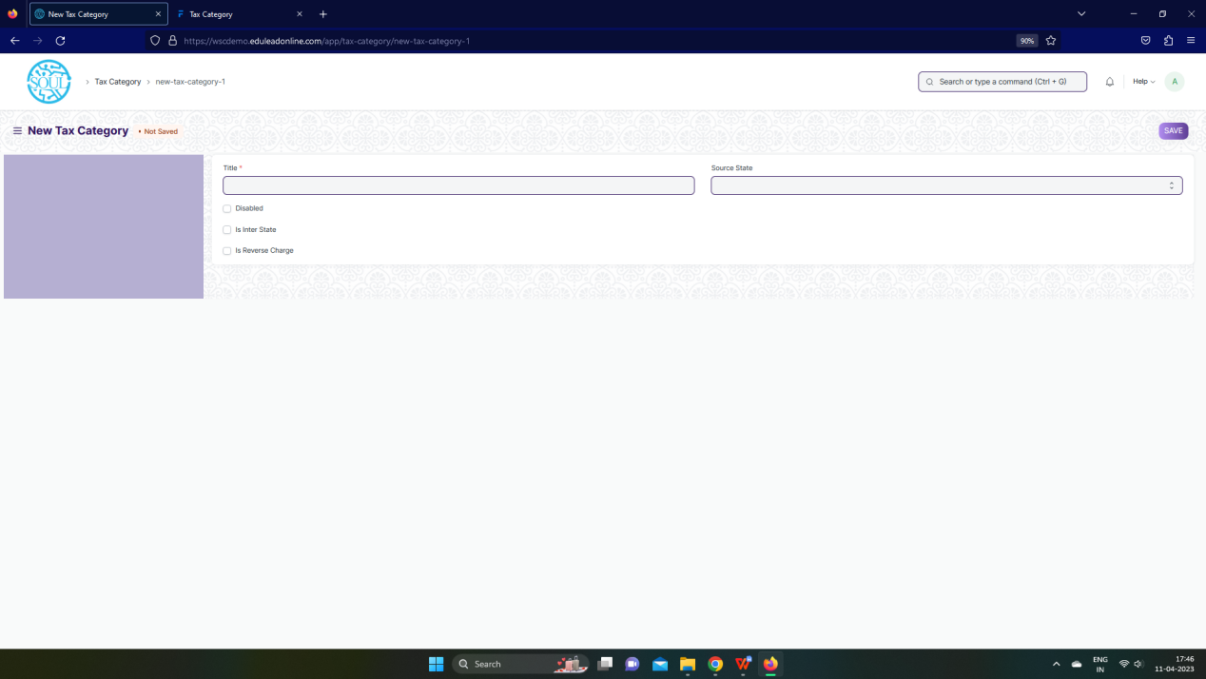Figure: Tax Category Screen

**UI Fields**

The “Tax Category” screen shall consist of the following fields:

|  |  |  |  |  |  |  |
| --- | --- | --- | --- | --- | --- | --- |
| **ID** | **Field Label** | **Field Type** | **Validation/ Action** | **Mandatory** | **Remarks** | **R/N/D** |
| 1 | Title | Text Field | User Input | Yes |  |  |
| 2 | Disabled | Checkbox | User Input |  |  |  |
| 3 | Is Inter State | Checkbox | User Input |  |  |  |
| 4 | Is Reverse Charge | Checkbox | User Input |  |  |  |
| 5 | Source State | Select | Andaman and Nicobar Islands/  Andhra Pradesh/  Arunachal Pradesh/  Assam/  Bihar/  Chandigarh/  Chhattisgarh/  Dadra and Nagar Haveli and Daman and Diu/  Delhi/  Goa/  Gujarat/  Haryana/  Himachal Pradesh/  Jammu and Kashmir/  Jharkhand/  Karnataka/  Kerala/  Ladakh/  Lakshadweep Islands/  Madhya Pradesh/  Maharashtra/  Manipur/  Meghalaya/  Mizoram/  Nagaland/  Odisha/  Other Territory/  Pondicherry/  Punjab/  Rajasthan/  Sikkim/  Tamil Nadu/  Telangana/  Tripura/  Uttar Pradesh/  Uttarakhand/  West Bengal |  |  |  |

**Users: Roles and Permissions**

The following table describes the users and their roles and permissions for the screens :

|  |  |  |  |  |  |  |  |  |
| --- | --- | --- | --- | --- | --- | --- | --- | --- |
| **ID** | **Role** | **Read** | **Write** | **Create** | **Delete** | **Submit** | **Cancel** | **Amend** |
| 1 | Account User | Yes | Yes | Yes | Yes | NA | NA | NA |
| 2 | Account Manager | Yes | Yes | Yes | Yes | NA | NA | NA |
| 3 | Accountant Admin | Yes | Yes | Yes | Yes | NA | NA | NA |

### Item Tax Template

**General Description**

The Following table describe overall information about this screen:

|  |  |
| --- | --- |
| **Description :** | Item Tax Template is useful for item wise taxation |
| **Navigation :** | Home > Accounts > Taxes > Item Tax Template |
| **Pre-requisites :** | NA |
| **Existing Screen Name** | Item Tax Template |
| **New Screen Name** | No change |

**Item Tax Template Screenshot**

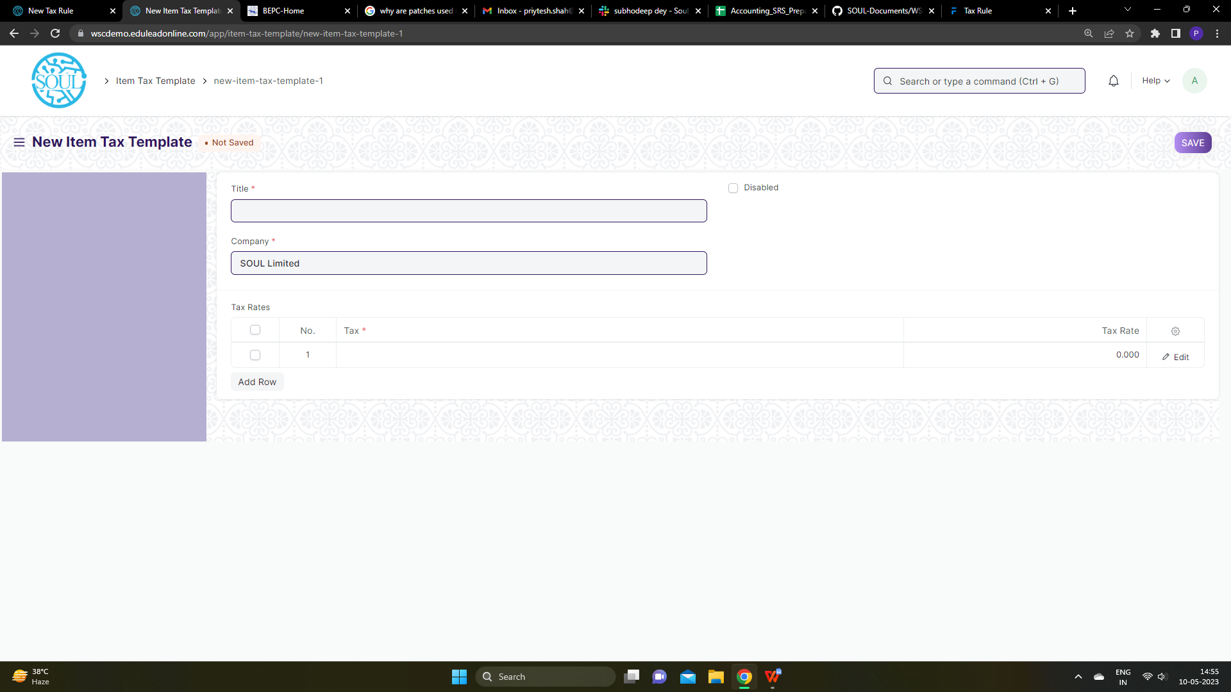Figure: Item Tax Template Screen

**UI Fields**

The “Item Tax Template” screen shall consist of the following fields:

|  |  |  |  |  |  |  |
| --- | --- | --- | --- | --- | --- | --- |
| **ID** | **Field Label** | **Field Type** | **Validation/ Action** | **Mandatory** | **Remarks** | **R/N/D** |
| 1 | Title | Text Field | User Input | Yes |  |  |
| 2 | Company | Link | Fetched from Company screen | Yes |  |  |
| 3 | Disabled | Checkbox | User Input |  |  |  |
| 4 | Tax Rates | Table |  | Yes | These table is describe below |  |

|  |  |  |  |  |  |  |
| --- | --- | --- | --- | --- | --- | --- |
| **Tax Rates (Child Table)** | | | | | | |
| **ID** | **Field Label** | **Field Type** | **Validation/ Action** | **Mandatory** | **Remarks** | **R/N/D** |
| 1 | Tax | Link | Fetched from Accounts screen | Yes |  |  |
| 2 | Tax Rate | Float | User Input |  |  |  |

**Users: Roles and Permissions**

The following table describes the users and their roles and permissions for the screens :

|  |  |  |  |  |  |  |  |  |
| --- | --- | --- | --- | --- | --- | --- | --- | --- |
| **ID** | **Role** | **Read** | **Write** | **Create** | **Delete** | **Submit** | **Cancel** | **Amend** |
| 1 | Account User | Yes | Yes | Yes | Yes | NA | NA | NA |
| 2 | Account Manager | Yes | Yes | Yes | Yes | NA | NA | NA |
| 3 | Accountant Admin | Yes | Yes | Yes | Yes | NA | NA | NA |

### Purchase Taxes and Charges Template

**General Description**

The Following table describe overall information about this screen:

|  |  |
| --- | --- |
| **Description :** | Purchase Taxes and Charges may be applied to any item you buy. |
| **Navigation :** | Home > Accounts > Taxes > Purchase Taxes and Charge Template |
| **Pre-requisites :** | 1. Company 2. Tax Category 3. Account |
| **Existing Screen Name** | Purchase Taxes and Charges Template |
| **New Screen Name** | No change |

**Purchase Taxes and Charges Template Screenshot**

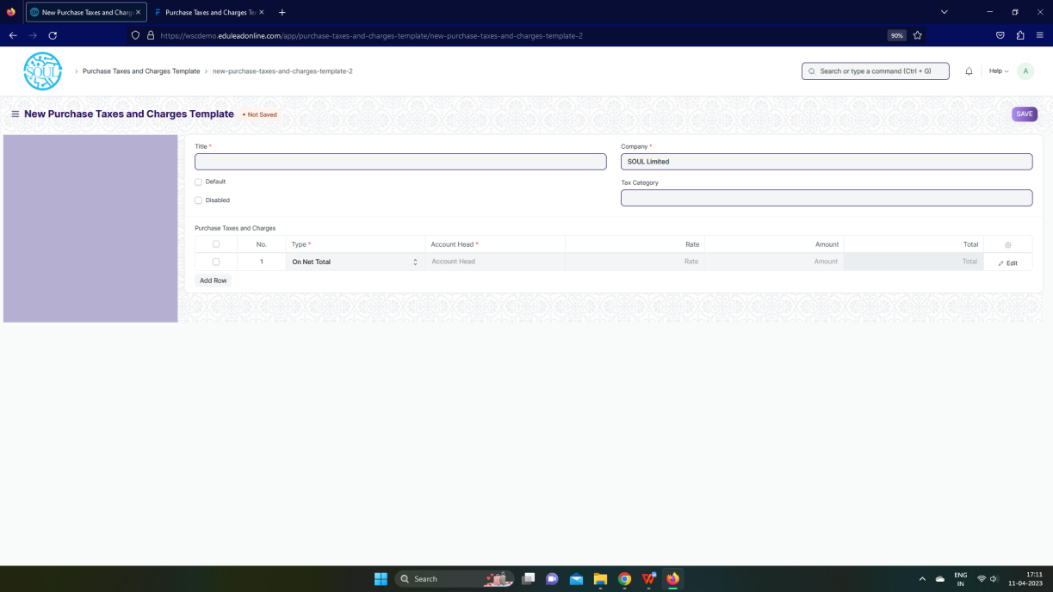

Figure: Purchase Taxes and Charges Template Screen

**UI Fields**

The “Purchase Taxes and Charges Template” screen shall consist of the following fields:

|  |  |  |  |  |  |  |
| --- | --- | --- | --- | --- | --- | --- |
| **ID** | **Field Label** | **Field Type** | **Validation/ Action** | **Mandatory** | **Remarks** | **R/N/D** |
| 1 | Title | Text Field | User Input | Yes |  |  |
| 2 | Default | Checkbox | User Input |  |  |  |
| 3 | Disabled | Checkbox | User Input |  |  |  |
| 4 | Company | Link | Fetched from Company screen | Yes |  |  |
| 5 | Tax Category | Link | Fetched from Tax Category screen |  |  |  |
| 6 | Purchase Taxes and Charges | Table |  |  | These table is describe below |  |
|  | **Purchase Taxes and Charges (Child Table)** | | | | | |
| **ID** | **Field Label** | **Field Type** | **Validation/ Action** | **Mandatory** | **Remarks** | **R/N/D** |
| 1 | Consider Tax or Charge for | Dropdown | Valuation and Total / Valuation / Total | Yes |  |  |
| 2 | Add or Deduct | Dropdown | Add / Deduct | Yes |  |  |
| 3 | Type | Dropdown | Actual / On Net Total / On previous row amount / On previous row Total / On Item Quantity | Yes |  |  |
| 4 | Is this Tax included in Basic Rate? | Checkbox | User Input |  |  |  |
| 5 | Considered In Paid Amount | Checkbox | User Input |  |  |  |
| 6 | Account Head | Link | Fetched from Account screen | Yes |  |  |
| 7 | Description | Small Text Field | User Input | Yes |  |  |
| 8 | Rate | Float | User Input |  |  |  |
| 9 | Address | Link | Fetched from Account screen |  |  |  |
| 10 | Article | Link | Fetched from Account screen |  |  |  |
| 11 | Cost Center | Link | Fetched from Account screen |  |  |  |
| 12 | About Us Team Member | Link | Fetched from Account screen |  |  |  |
| 13 | Account Currency | Link | Fetched from Account screen |  |  |  |
| 14 | Amount | Currency | Calculated on the basis of user input of rate |  |  |  |
| 15 | Tax Amount After Discount Amount | Currency | Calculated on the basis of user input of rate |  |  |  |
| 16 | Total | Currency | Calculated on the basis of user input of rate |  |  |  |
| 17 | Amount (Company Currency) | Currency | Calculated on the basis of user input of rate |  |  |  |
| 18 | Total (Company Currency) | Currency | Calculated on the basis of user input of rate |  |  |  |
| 19 | Tax Amount After Discount Amount | Currency | Calculated on the basis of user input of rate |  |  |  |

**Users: Roles and Permissions**

The following table describes the users and their roles and permissions for the screens :

|  |  |  |  |  |  |  |  |  |
| --- | --- | --- | --- | --- | --- | --- | --- | --- |
| **ID** | **Role** | **Read** | **Write** | **Create** | **Delete** | **Submit** | **Cancel** | **Amend** |
| 1 | Account User | Yes | Yes | Yes | Yes | NA | NA | NA |
| 2 | Account Manager | Yes | Yes | Yes | Yes | NA | NA | NA |
| 3 | Accountant Admin | Yes | Yes | Yes | Yes | NA | NA | NA |

### Tax Rule

**General Description**

The Following table describe overall information about this screen:

|  |  |
| --- | --- |
| **Description :** | A Tax Rule automatically applies taxes to transactions based on preset rules. |
| **Navigation :** | Home > Accounts > Taxes > Purchase Taxes and Charge Template |
| **Pre-requisites :** | 1. Company 2. Tax Category 3. Account |
| **Existing Screen Name** | Tax rule |
| **New Screen Name** | No change |

**Tax Rule Screenshot**

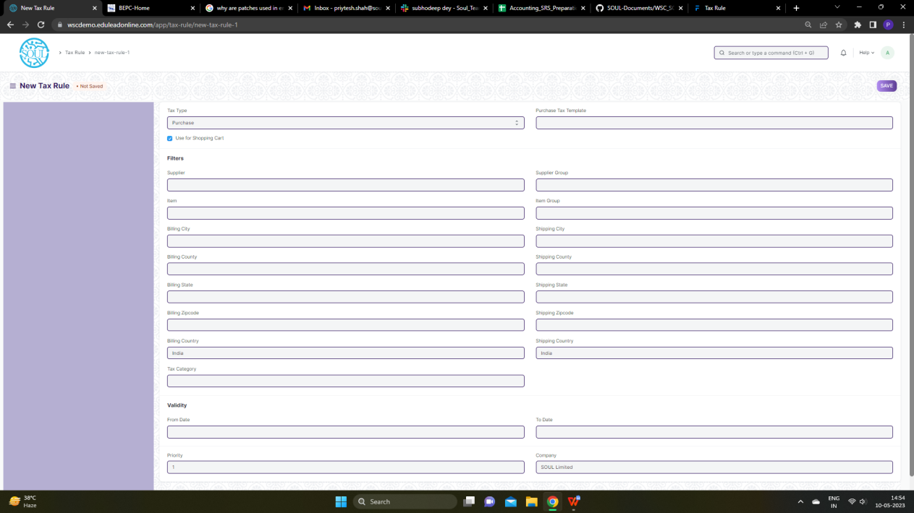

Figure: Tax Rule Screen

**UI Fields**

The “Tax Rule” screen shall consist of the following fields:

|  |  |  |  |  |  |  |
| --- | --- | --- | --- | --- | --- | --- |
| **ID** | **Field Label** | **Field Type** | **Validation/ Action** | **Mandatory** | **Remarks** | **R/N/D** |
| 1 | Tax Type | Dropdown | Sales / Purchase |  |  |  |
| 2 | Use for Shopping Cart | Checkbox | User Input |  |  |  |
| 3 | Sales Tax Template | Link | Fetched from Sales Tax Template screen |  |  |  |
| 4 | Purchase Tax Template | Link | Fetched from Purchase Tax Template screen |  |  |  |
| 5 | Customer | Link | Fetched from Customer screen |  |  |  |
| 6 | Supplier | Link | Fetched from Supplier screen |  |  |  |
| 7 | Item | Link | Fetched from Item screen |  |  |  |
| 8 | Billing City | Text field | User Input |  |  |  |
| 9 | Billing County | Text field | User Input |  |  |  |
| 10 | Billing State | Text field | User Input |  |  |  |
| 11 | Billing Zipcode | Text field | User Input |  |  |  |
| 12 | Billing Country | Link | Fetched from Country screen |  |  |  |
| 13 | Tax Category | Link | Fetched from Tax Category screen |  |  |  |
| 14 | Customer Group | Link | Fetched from Supplier Group screen |  |  |  |
| 15 | Supplier Group | Link | Fetched from Supplier Group screen |  |  |  |
| 16 | Item Group | Link | Fetched from Item Group screen |  |  |  |
| 17 | Shipping City | Text field | User Input |  |  |  |
| 18 | Shipping County | Text field | User Input |  |  |  |
| 19 | Shipping State | Text field | User Input |  |  |  |
| 20 | Shipping Zipcode | Text field | User Input |  |  |  |
| 21 | Shipping Country | Link | Fetched from Country screen |  |  |  |
| 22 | From Date | Date | User Input |  |  |  |
| 23 | To Date | Date | User Input |  |  |  |
| 24 | Priority | Int | User Input |  |  |  |
| 25 | Company | Link | Fetched from Company screen |  |  |  |

**Users: Roles and Permissions**

The following table describes the users and their roles and permissions for the screens :

|  |  |  |  |  |  |  |  |  |
| --- | --- | --- | --- | --- | --- | --- | --- | --- |
| **ID** | **Role** | **Read** | **Write** | **Create** | **Delete** | **Submit** | **Cancel** | **Amend** |
| 1 | Account User | Yes | Yes | Yes | Yes | NA | NA | NA |
| 2 | Account Manager | Yes | Yes | Yes | Yes | NA | NA | NA |
| 3 | Accountant Admin | Yes | Yes | Yes | Yes | NA | NA | NA |

### Tax Withholding Category

**General Description**

The Following table describe overall information about this screen:

|  |  |
| --- | --- |
| **Description :** | Tax Withholding Category is Tax Deducted at Source. |
| **Navigation :** | Home > Accounts > Taxes > Tax Withholding Category |
| **Pre-requisites :** | 1. Supplier 2. Customer |
| **Existing Screen Name** | Tax Withholding Category |
| **New Screen Name** | No change |

**Tax Withholding Category Screenshot**

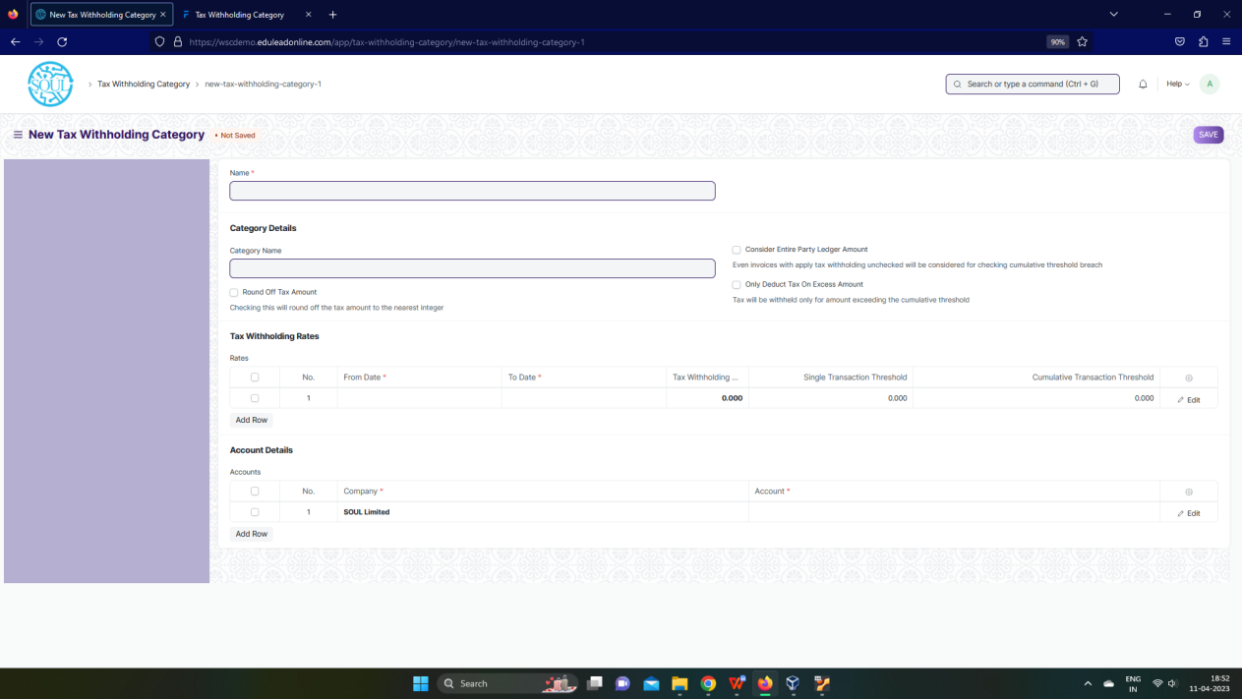

Figure: Tax Withholding Category Screen

**UI Fields**

The “Tax Withholding Category” screen shall consist of the following fields:

|  |  |  |  |  |  |  |
| --- | --- | --- | --- | --- | --- | --- |
| **ID** | **Field Label** | **Field Type** | **Validation/ Action** | **Mandatory** | **Remarks** | **R/N/D** |
| 1 | Category Name | Text Field | User Input |  |  |  |
| 2 | Round Off Tax Amount | Checkbox | User Input |  |  |  |
| 3 | Consider Entire Party Ledger Amount | Checkbox | User Input |  |  |  |
| 4 | Only Deduct Tax On Excess Amount | Checkbox | User Input |  |  |  |
| 5 | Rates | Table |  | Yes | These table is describe below |  |
| 6 | Accounts | Table |  | Yes | These table is describe below |  |
|  | **Rates (Child Table)** | | | | | |
| **ID** | **Field Label** | **Field Type** | **Validation/ Action** | **Mandatory** | **Remarks** | **R/N/D** |
| 1 | From Date | Date | User Input | Yes |  |  |
| 2 | To Date | Date | User Input | Yes |  |  |
| 3 | Tax Withholding Rate | Float | User Input | Yes |  |  |
| 4 | Single Transaction Threshold | Float | User Input |  |  |  |
| 5 | Cumulative Transaction Threshold | Float | User Input |  |  |  |
| 6 | Due Date Based On | Dropdown | Day(s) after invoice date /  Day(s) after the end of the invoice month /  Month(s) after the end of the invoice month |  |  |  |
| 7 | Credit Days | Int | User Input |  |  |  |
| 8 | Credit Months | Int | User Input |  |  |  |
| 9 | Discount Type | Dropdown | Percentage /  Amount |  |  |  |
| 10 | Discount | Float | User Input |  |  |  |
| 11 | Discount Validity Based On | Dropdown | Day(s) after invoice date /  Day(s) after the end of the invoice month /  Month(s) after the end of the invoice month |  |  |  |
| 12 | Discount Validity | Int | User Input |  |  |  |

|  |  |  |  |  |  |  |
| --- | --- | --- | --- | --- | --- | --- |
| **Accounts (Child Table)** | | | | | | |
| **ID** | **Field** Label | **Field** Type | **Validation/ Action** | **Mandatory** | **Remarks** | **R/N/D** |
| 1 | Company | Link | Fetched from Company screen | Yes |  |  |
| 2 | Account | Link | Fetched from Account screen | Yes |  |  |

**Users: Roles and Permissions**

The following table describes the users and their roles and permissions for the screens :

|  |  |  |  |  |  |  |  |  |
| --- | --- | --- | --- | --- | --- | --- | --- | --- |
| **ID** | **Role** | **Read** | **Write** | **Create** | **Delete** | **Submit** | **Cancel** | **Amend** |
| 1 | Account User | Yes | Yes | Yes | Yes | NA | NA | NA |
| 2 | Account Manager | Yes | Yes | Yes | Yes | NA | NA | NA |
| 3 | Accountant Admin | Yes | Yes | Yes | Yes | NA | NA | NA |

## Bank Guarantee

### Bank Guarantee

**General Description**

The Following table describe overall information about this screen:

|  |  |
| --- | --- |
| **Description :** | A Bank Guarantee is a guarantee from a lending institution such as a bank ensuring the liabilities of a debtor will be met.  In other words, if the debtor fails to settle a debt, the bank covers it. A Bank Guarantee enables the customer, or debtor, to acquire goods, buy equipment or draw down loans, and thereby expand business activity. |
| **Navigation :** | Home > Accounts |
| **Pre-requisites :** | Purchase Order |
| **Existing Screen Name** | Bank Guarantee |
| **New Screen Name** | No change |

**Bank Guarantee Screenshot**

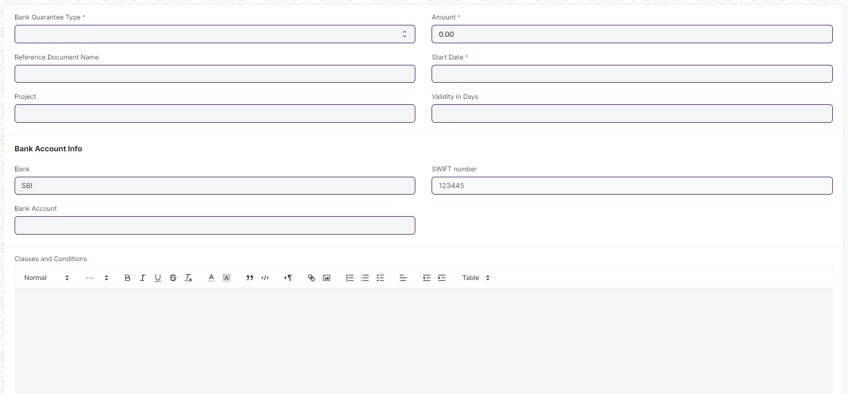

Figure: Bank Guarantee Screen

**UI Fields**

The “Bank Guarantee” screen shall consist of the following fields:

|  |  |  |  |  |  |  |
| --- | --- | --- | --- | --- | --- | --- |
| **ID** | **Field Label** | **Field Type** | **Validation/ Action** | **Mandatory** | **Remarks** | **R/N/D** |
| 1 | Bank Guarantee Type | Select |  | Yes |  |  |
| 2 | Reference Document Type | Link Field | Fetched based on Bank Guarantee Type(if type is "providing" will fetch Purchase Order) |  |  |  |
| 3 | Reference Document Name | Dynamic Link | Value will be fetched from Purchase Order and user will select any one |  |  |  |
| 5 | Supplier | Link Field | Value will be fetched from Supplier and user will select any one |  |  |  |
| 6 | Project | Link Field | Value will be fetched from Project and user will select any one |  |  |  |
| 7 | Amount | Currency | User will enter the Bank Guarantee Amount | Yes |  |  |
| 8 | Start Date | Date | User will provide the start date | Yes |  |  |
| 9 | Validity in Days | Number | User will enter the validity |  |  |  |
| 10 | End Date | Date | User will provide the end date |  |  |  |
| 12 | Bank | Link Field | Value will be fetched from Bank and user will select any one |  |  |  |
| 13 | Bank Account | Link Field | Value will be fetched from Bank Account and user will select any one |  |  |  |
| 14 | Account | Link Field | Value will be fetched from Account as the user selects the Bank Account |  |  |  |
| 15 | Bank Account No | Data | Value will be fetched from Bank Account as the user selects the Bank Account |  |  |  |
| 16 | IBAN | Data | Value will be fetched from Bank Account once user selects Bank Account |  |  |  |
| 17 | Branch Code | Data | Value will be fetched from Bank Account once user selects Bank Account |  |  |  |
| 18 | SWIFT number | Data | Value will be fetched from Bank once user selects Bank |  |  |  |
| 19 | Clauses and Conditions | Text Editor |  |  |  |  |
| 21 | Bank Guarantee Number | Data |  |  |  |  |
| 22 | Name of Beneficiary | Data |  |  |  |  |
| 23 | Margin Money | Currency |  |  |  |  |
| 24 | Charges Incurred | Currency |  |  |  |  |
| 25 | Fixed Deposit Number | Data |  |  |  |  |

**Users: Roles and Permissions**

The following table describes the users and their roles and permissions for the screens :

|  |  |  |  |  |  |  |  |  |
| --- | --- | --- | --- | --- | --- | --- | --- | --- |
| **ID** | **Role** | **Read** | **Write** | **Create** | **Delete** | **Submit** | **Cancel** | **Amend** |
| 1 | Account User | Yes | Yes | Yes | Yes | NA | NA | NA |
| 2 | Account Manager | Yes | Yes | Yes | Yes | NA | NA | NA |
| 3 | Accountant Admin | Yes | Yes | Yes | Yes | NA | NA | NA |